Contents

Introduction 1

Prerequisites 1

Attach Empty Disk to VM 1

Add Empty Disk to Linux 3

Find New Disk 3

Create New Partition 4

Create File System 5

Mount New Disk 6

Mount Disk (Temporarily) 6

Mount Disk (Persistent) 7

Adding Data Disk to Windows VM 8

# Introduction

This guide shows how to attach new disks to both Linux and Windows virtual machines.

# Attach Empty Disk to VM

You can attach a data disk to a virtual machine to store application data. A data disk is a Virtual Hard Disk (VHD) that you can create either locally with your own computer or in the cloud with Windows Azure. You manage data disks in the virtual machine the same way you do on a server in your office.

Go to the Azure management portal at <https://manage.windowsazure.com>, select “Virtual Machines” from the bar on the left, click on the VM you want to add the disk to and then go to “Dashboard” at the top bar:

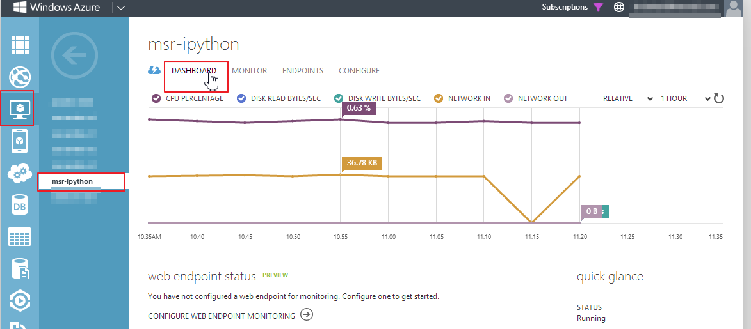

In the bar at the bottom, select “Attach” and then “Attach Empty Disk”:



A wizard will open asking you to configure the empty disk. Select a storage location, the file name and the size in GB. In addition, you can choose among the following caching modes:

* Read Only: Reads and writes are cached for future reads but writes are persisted directly to storage
* Read Write: Reads and writes are cached for future reads. Non-write-through writes are persisted to the local cache first, then lazily flushed to the Windows Azure Blob service. For SQL Server, writes are always persisted to Windows Azure Storage because it uses write-through
* None (disabled): Requests bypass the cache completely.

The best option to use depends on your intended usage. Read/Write offers the best performance in general, but depending on the type of service you want to use (SQL Server, Apache Cassandra), caching might be counter-productive.

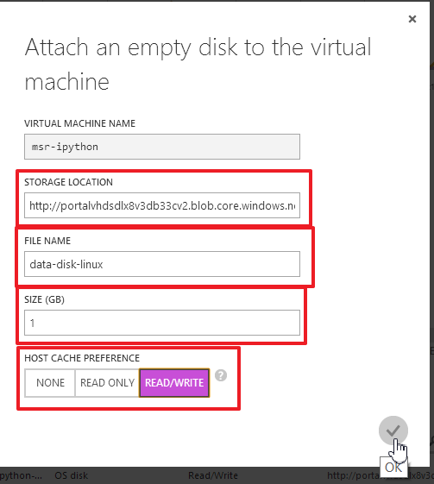In this example, select Read/Write. You can change this setting later if desired:

The operation might take a couple of moments. After that, you should see your disk attached on the VM dashboard in the portal (note that the disk count might need a reload to update):

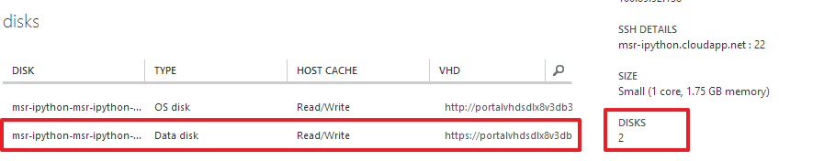

# Add Empty Disk to Linux

After you created the new disk, you need to format it and then mount it in your Linux VM.

First, connect to the virtual machine using SSH (or Putty).

## Find New Disk

Run the following command:

ls /dev/sd*

This shows you all the disks attached to the virtual machine. The new disk is attached at /dev/sdc by default:



You can also check the mounted disks with the command:

df -h

You will see that /dev/sdc is not yet mounted as it is not present in the listing:

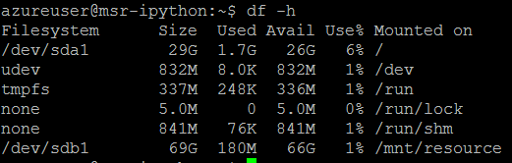

## Create New Partition

You need to format the disk to use it. Execute the following command:

sudo fdisk /dev/<device>

In our example:

sudo fdisk /dev/sdc

When prompted, first enter “n” (new partition), then “p” (primary partition). You can leave the rest of the values at default. This will create a partition over the whole disk. At the end, enter “w” to write the changes to disk:

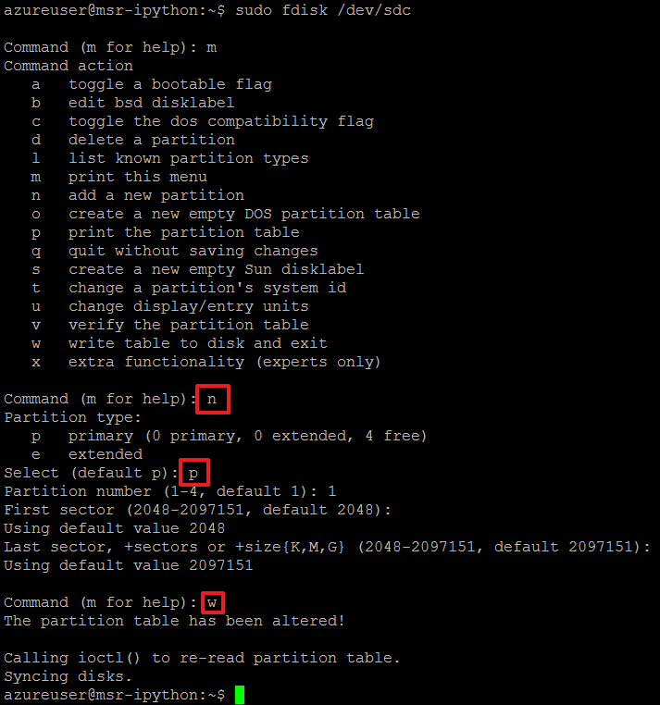

Now list the devices again:

ls /dev/sd*

You should see that a new directory “/dev/sdc1” was added. This directory represents the newly created partition 1 on disk sdc:



## Create File System

Next, you need to create a file system. In this example, you will use “ext4” as filesystem:

sudo mkfs -t ext4 /dev/sdc1

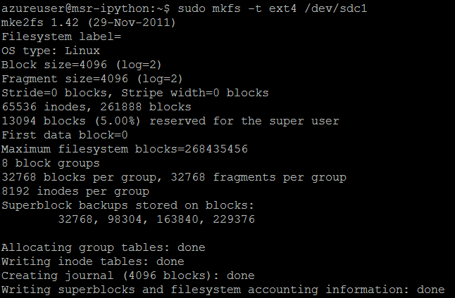

## Mount New Disk

In the last step, you need to mount the disk. On Linux system, disks are mounted into a directory of your choice, meaning that everything in this directory or in its sub directories are stored on the particular disk/partition.

A common location to mount disks is to use a subdirectory of “/mnt”. For this example, create the directory “/mnt/data” as place to store the data:

sudo mkdir /mnt/data

### Mount Disk (Temporarily)

You can mount the disk with the following command:

sudo mount /dev/sdc1 /mnt/data

This will mount the device /dev/sdc1 to /mnt/data. Using the command:

df -h

again, you should see the mounted disk:

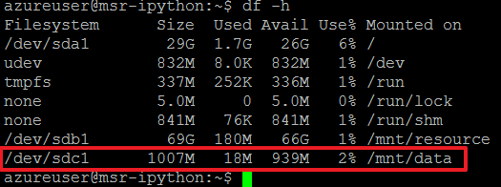

This approach has one drawback: If you reboot the virtual machine, you have to manually mount the disk again. In the next step, you will make the mount configuration persistent.

### Mount Disk (Persistent)

Unmount the disk you mounted in the previous step:

sudo umount /mnt/data

Next, you need to open an editor to edit /etc/fstab, the file which holds the partitions to mount during startup:

sudo nano /etc/fstab

The format in /etc/fstab is:

[Device] [Mount Point] [File System Type] [Options] [Dump] [Pass]

Paste the following configuration into a new line in the editor:

/dev/sdc1 /mnt/data ext4 defaults 0 0

Then press ctrl+x to exit. Confirm saving with “y” and then enter.

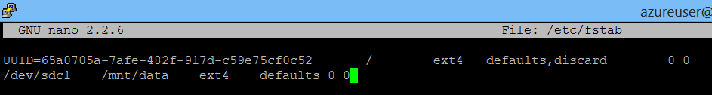

Now you should try to mount the disks in fstab. This can be done with:

sudo mount -a

There should be no output if successful. Again, you can check the new partition using:

df -h



# Adding Data Disk to Windows VM

To administrate your Windows VM, you need to login via remote desktop (RDP).

Start the server manager from the taskbar:

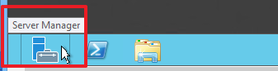

Navigate to “File and Storage Services” and select the newly created disk (with partition “Unknown”):

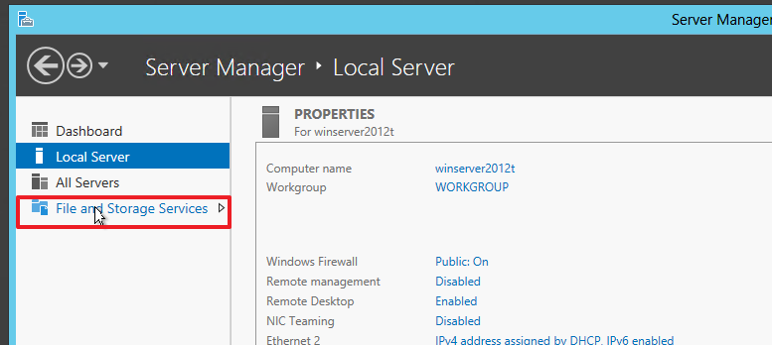

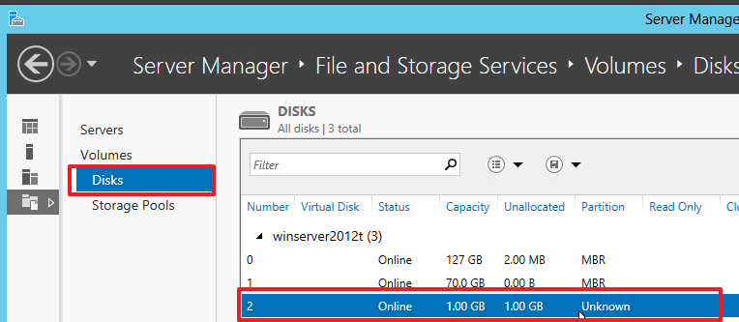

Right click on the new disk and select “Initialize”:

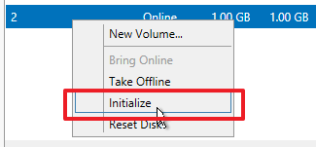

A warning will popup. You can safely ignore it as this disk is empty:

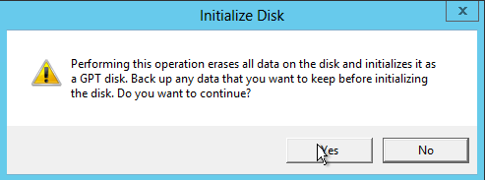

The initialization process should finish rather quickly. Afterwards, right click on the now initialized disk and select “New volume”:

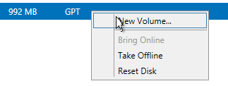

A wizard will start. Skip the first section “Before you begin”. On the second screen, make sure that your new disk is select and click on “Next”:

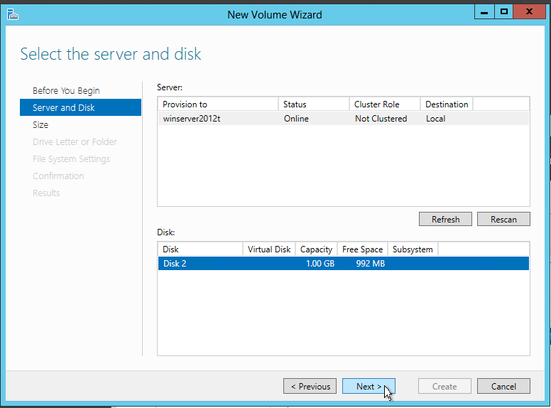

On the next page, you can define the size of the volume. The maximum size is selected as default:

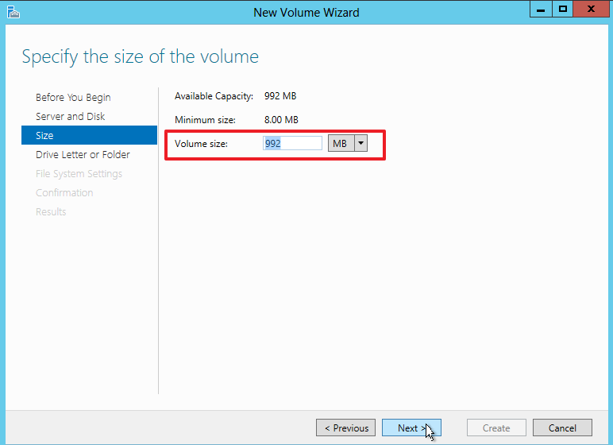

On the next screen, you can assign a drive letter for the new volume, or you can mount it in a particular folder. Choose a drive letter and select “Next”:

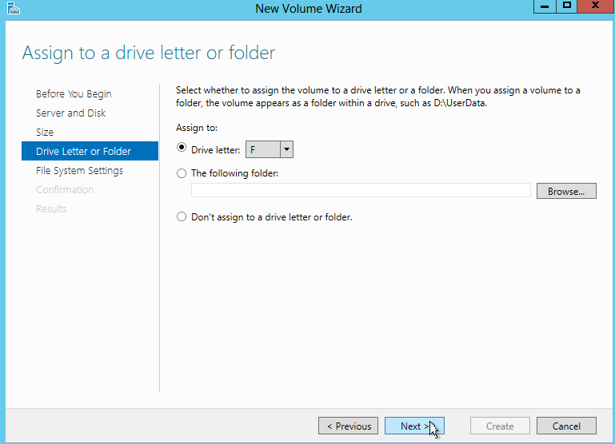

On the next screen, you can select the file system and name the new volume:

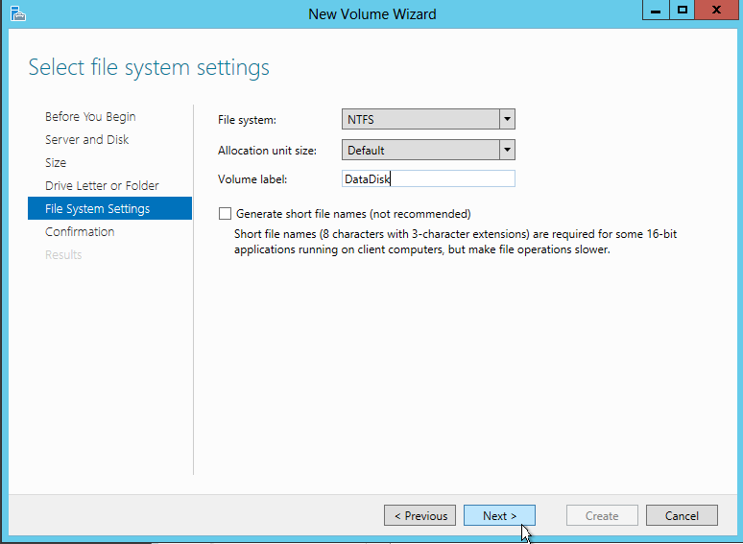

Confirm your selection on the Confirmation screen, then select “Create”. The new volume will be created and mounted:

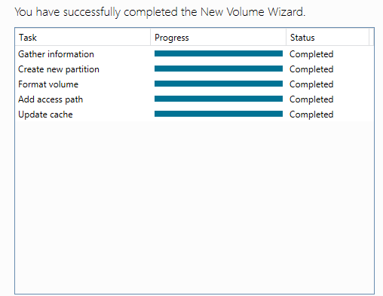

Click on “Close”. If you select your new disk again, you should see the new volume in the “Volumes” window:

